**CST8257 Web Application Development**

Lab 6

# Objective

1. Upload and Download files in PHP.
2. Processing (resize and rotate) images in PHP

# Due Date

See Canvas post for the due date of this lab. To earn 5 points, you are required:

1. Complete the lab as required.
2. Submit your lab work to the Canvas.
3. Demonstrate your lab work during the following week’s lab session.

# Requirements

Create an online Picture Gallery PHP application. The application consists of three pages:

1. **Index.php** – The Landing (or Home) page of the application:

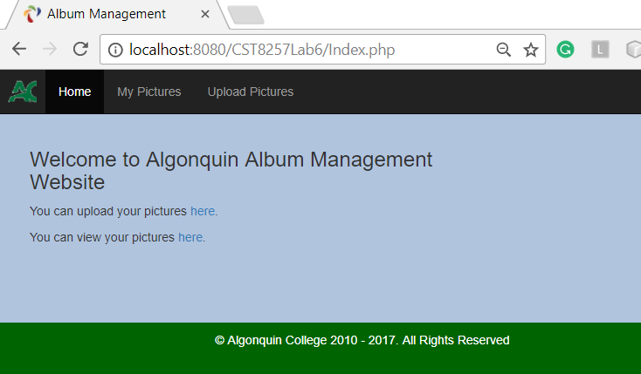

1. **UploadPicture.php** – The use can use this page to upload one or more pictures of JPEG, GIF and PNG types.

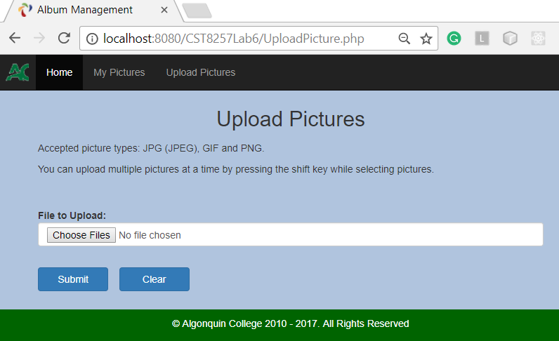

On submission, for each picture the user selected to upload to the server, the application saves three versions of the picture:

* Original – The picture in its original height and width pixel size for user to download the picture in its original quality later.
* Album – The reduced size (1024 x 800 pixels) of the picture for displaying in browsers. The application should resample the original picture to a small size for quick transmitting to browsers, also to prevent the original high quality picture from being stolen by others while viewing the picture online.
* Thumbnail – The thumbnail size (100 * 100 pixels) of the picture for displaying in the thumbnail stripe serving as the preview of the picture as well as the button for the user to click to view the picture in the browser.

Hints:

* You can use the following folder structure. The three versions of the same picture can have the same name but reside in their own folder, respectively. In this way, you can easily get the file path of a picture’s different version by changing folder name only.

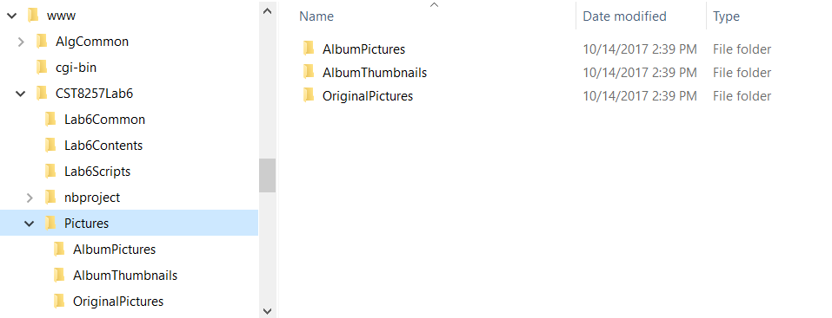

* You can define a Picture class as on the following page. An object of this class does not contain a picture itself, instead, it encapsulate the accessing paths to the picture.

**ConstantsAndSettings.php** defines all the constants used in the application.

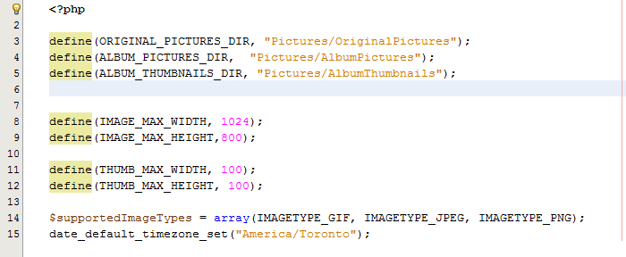

The class’s **public static function getPictures( ) { …** **}** returns an array of all picture objects representing the picture files found inside folder ALBUM_THUMBNAILS_DIR. The array is associative with the Id of the pictures as keys.

All other attributes and methods are self-explanatory.

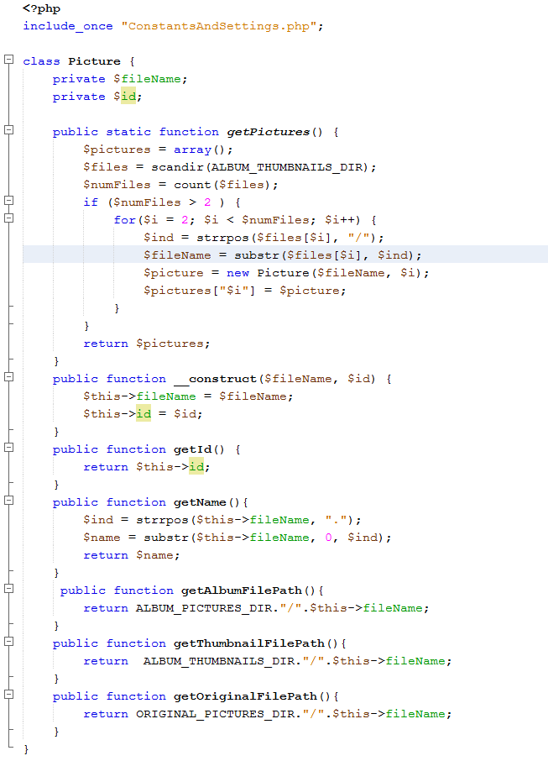

1. **MyPictures.php** – The user can use this page to perform the following tasks:

* Browse his/her pictures stored on the server by clicking its thumbnail in the thumbnail stripe.

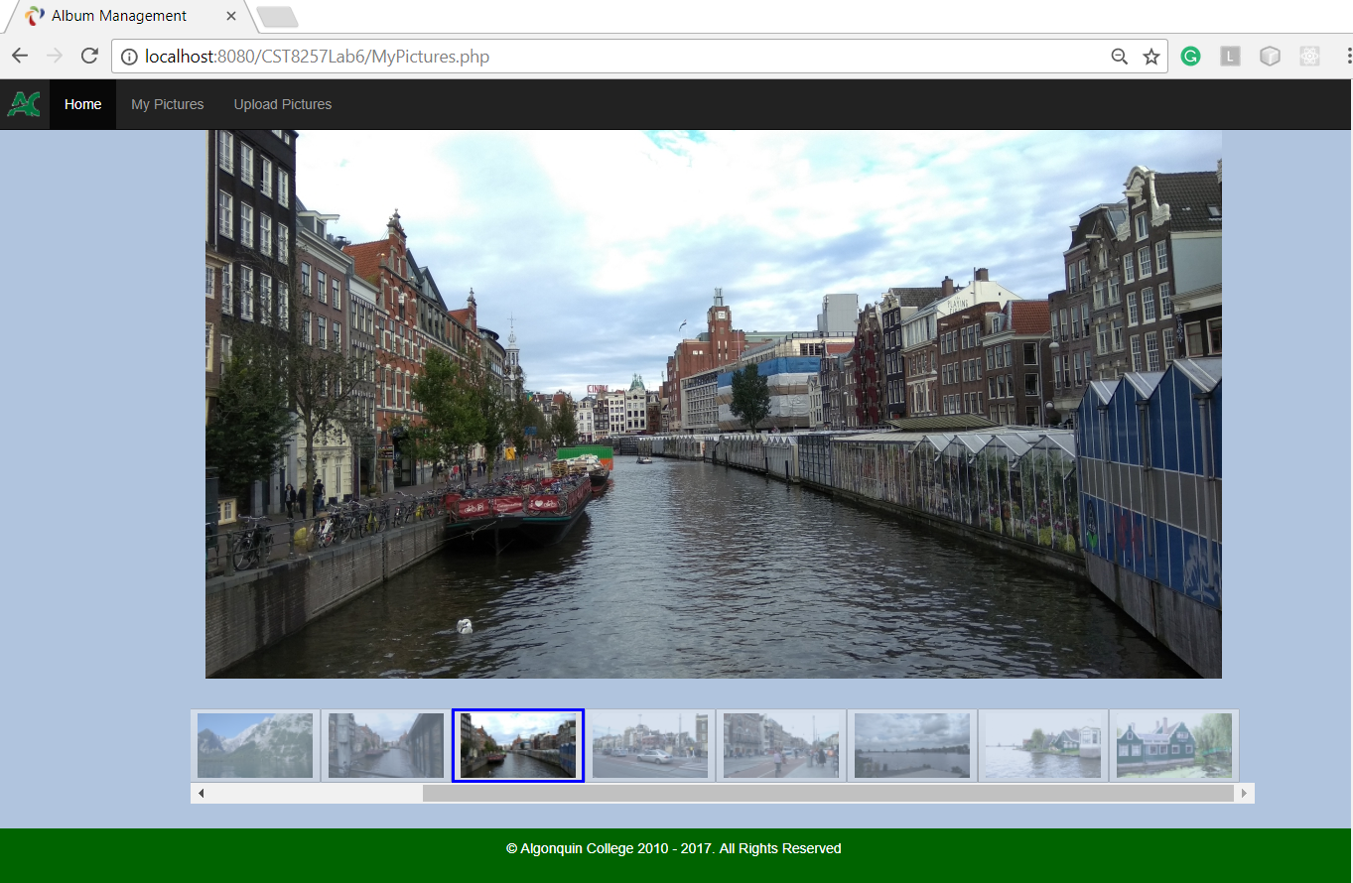

* The user can select to rotate (left or right), download and delete the picture from the server by hovering the mouse over the picture and click one of the icons for these actions, respectively.

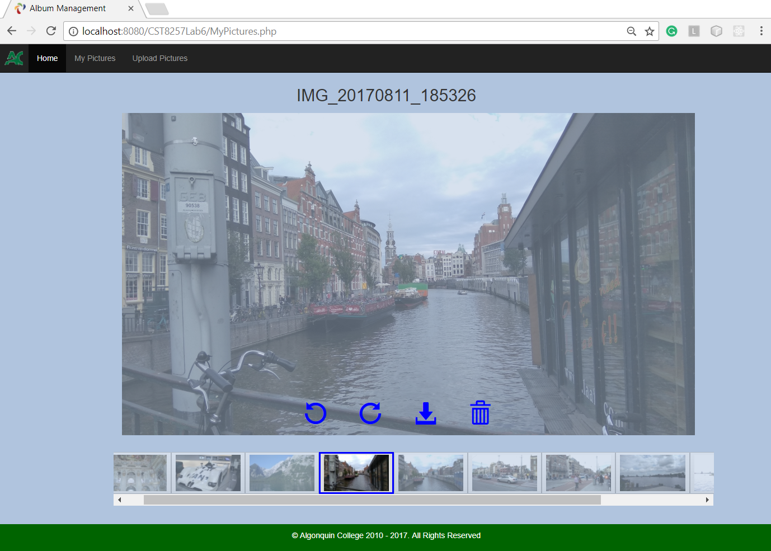

**Hints:**

* The icons for rotation, downloading and trashcan come from Bootstrap. There are many very useful icons included in Bootstrap, see following link for details:

<https://www.w3schools.com/bootstrap/bootstrap_ref_comp_glyphs.asp>

* The following CSS classes let you
  + Flip an icon
  + Dim the picture and show action icons when hovering over the picture

